**LAB REPORT**

Course Code - Course Name: - COMP4041 - Operating System

Program: T433 - Cybersecurity

Term: - Winter 2024

Lab Number - Topic: Lab 3 – **User accounts and groups**

Student Names - ID: Prabhjot Singh Sains – 101495218

**Part 1: Create group and user accounts**

1. Create a group called “developers” using “addgroup” command. (Ans 1)

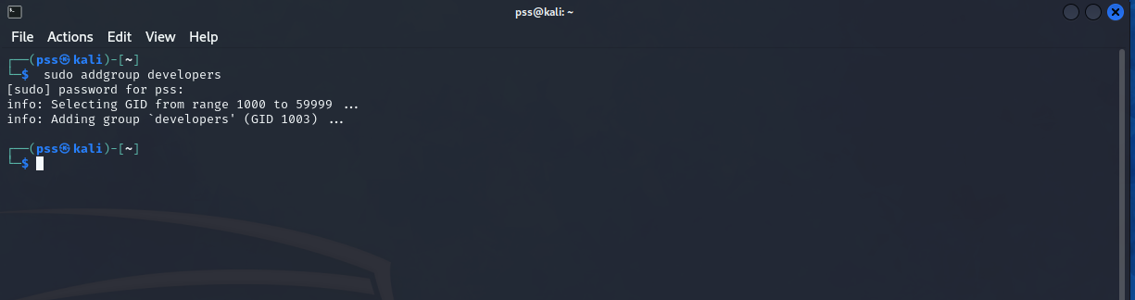

1. Make a directory /projects/bigdeal (Ans 2)

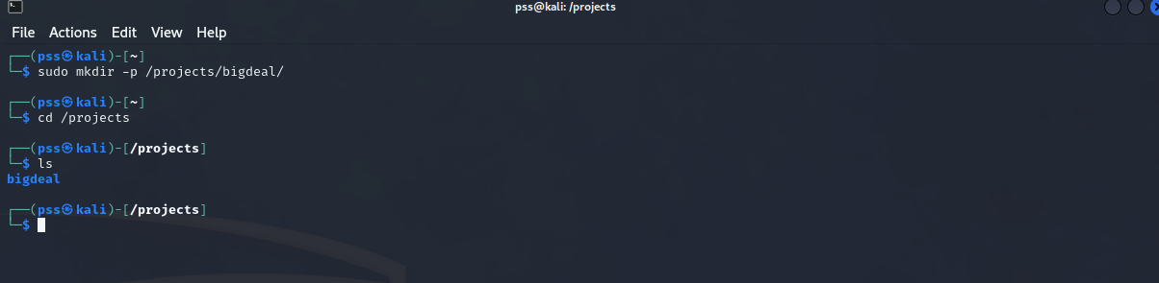

1. Make sure /projects/bigdeal is owned by “root” and belongs to “developers” group (Ans 3)



1. The directory must be full access for the owner and the group, with no access for any other users and it must have the set-group-id bit turned on. (Ans 4)

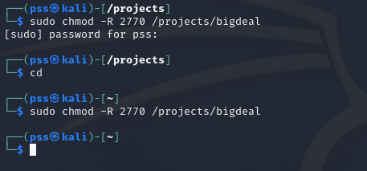

1. Create a subdirectory incoming under bigdeal: /projects/bigdeal/incoming, and verify that the “incoming” directory have full access for the owner and the group, with no access for any other users and it must have the set-group-id bit turned on as well (same as its parent directory). Show the output of sudo ls -la /projects/bigdeal

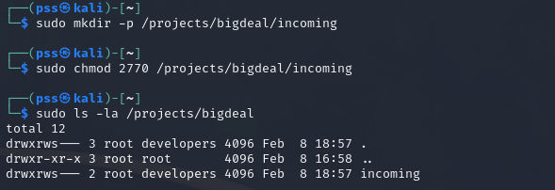

1. Create user accounts for harry, sally, and cupid.

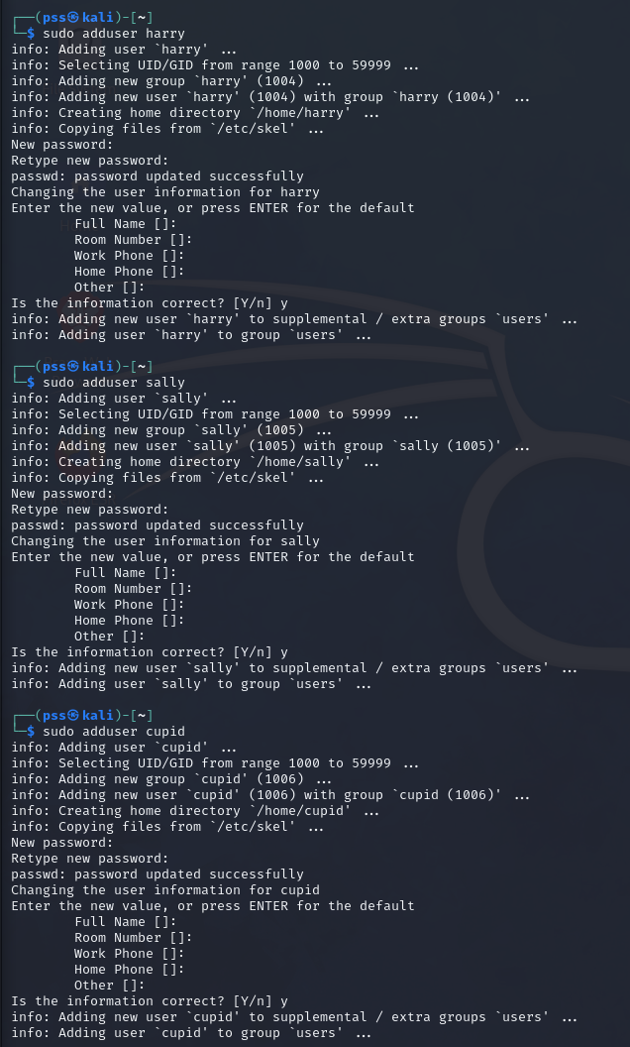

1. Add all three user accounts to “developers” group:

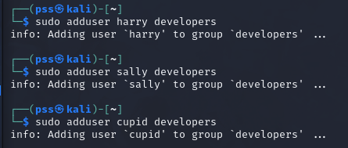

**Part 2: user collaboration!**

1. Log in to harry account and create a file called myclothes.txt. Add 5 lines of text in this file containing some clothing items. Then copy the file to the project's incoming folder with the filename “harry” as shown below.

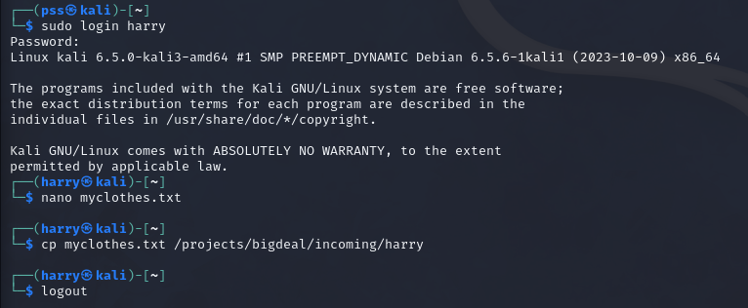

1. Log in to sally account. Create a file named myfurniture.txt with 5 lines of text containing some furniture items. Then copy the file to the project's incoming folder with filename “sally”. Again, the commands are shown below.

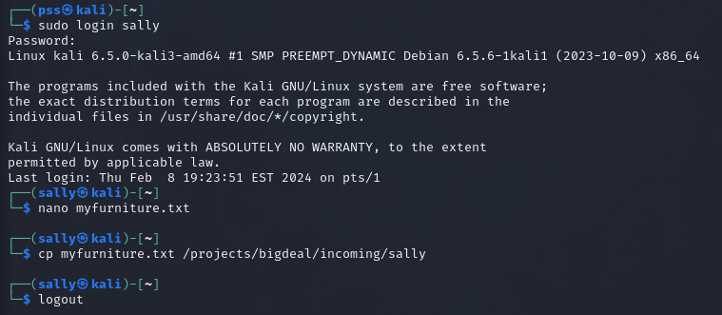

1. Log into the Cupid account and perform the following tasks:
   1. Using the paste command create a file called “when-harry-met-sally.txt” in /projects/bidgeal/

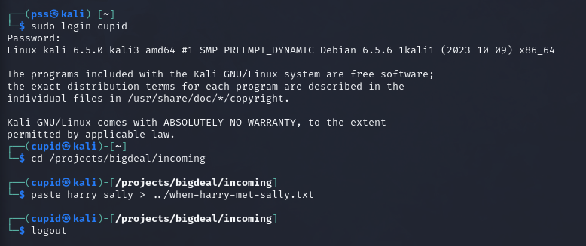

* 1. Use the cat command to display the contents of the file:

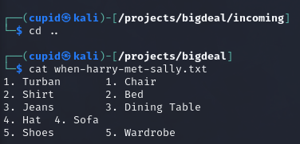

**Assignment**

**1.**

**Part 1:**

**Ans 1:** sudo addgroup developers

**Ans 2:** sudo mkdir -p /projects/bigdeal/

**Ans 3:** sudo chown root:developers /projects/bigdeal

**Ans 4:** sudo chmod -R 2770 /projects/bigdeal

**Ans 5:** total 8

drwxrws--- 3 root developers 4096 Feb 7 10:00 .

drwxr-xr-x 16 root root 4096 Feb 7 09:59 ..

drwxrws--- 2 root developers 4096 Feb 7 10:00 incoming

2.



